Karin Scheidegger
Schifflaube 40
CH-3011 Bern

post@karinscheidegger.ch
www.karinscheidegger.ch
+41 79 742 44 10
TO WHOM IT MAY CONCERN

Protocol of Events – 17.04.2013 – RAWAN village – Baloda-Bazar – Bhattapara-Road

- 5.45am Karin Scheidegger and Ajay T.G. leave Hotel Pradeep in Baloda-Bazaar in order to catch the atmospheric early morning light.
- Our aim was to document the life of people around Baloda-Bazar district and their living conditions – we did not intend to intrude anywhere and by no means it was our intention to get involved into any illegal action.
- By about 6.15am I asked Ajay to stop the car near the Ambuja gate as it was an interesting sight to see all the workers leaving from their shift – I took a few street shots and was amused by the sign at the main gate saying "AMBUJA CEMENT WELCOMES YOU FOR A SAFE & PLEASANT VIST"
This was no act of espionage but just catching local dominant sights that appealed to me visually.
- We spent no more than two minutes near the Ambuja Gate when we were told by the security guard to leave and that we were not allowed to take photographs from anywhere closer than 500m (Ajay translated for me) – I kindly apologised and the guard asked “where are you from?” – I said “Switzerland” and we left the spot and drove further down the road leaving Rawan village behind us.
- About 2 km outside Rawan village I wanted to take a shot of the contrast between the dominating local industry and the farming field. Yet again I asked Ajay to stop the car.
This is the picture that I took just a few minutes before the incident happened:
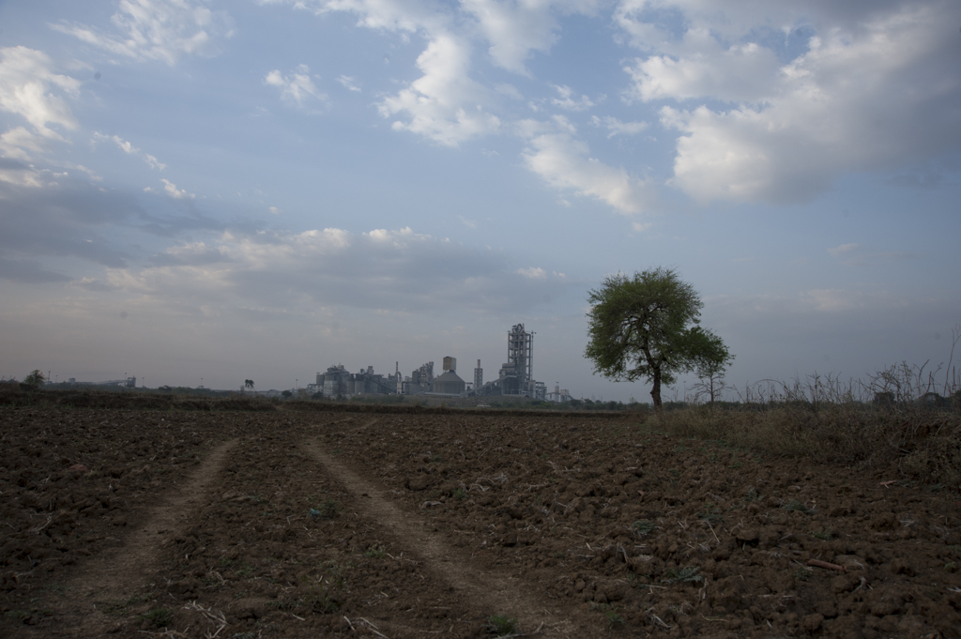
- Ajay was waiting for me at the car and I stepped about 100 m away from the car into the field to take the picture. When I came back to the car there were two men in Ambuja-workers-vest standing next to Ajay arguing. I did not understand what the argument was about as they were talking in their local language. I was worried about my camera as I thought they might take it from me and went silently back to the car – hoping we could leave shortly as I started to feel uncomfortable with the situation (Ajay mentioned later that he thinks the two workers willingly followed our car after we drove away from the gate).
- Ajay’s Resume of the conversation:
First when they arrived they took a picture with their mobile-phone of his car-number-plate and started severely swearing at him and verbally assaulting him. Ajay asked “why are you doing that?” and they replied “we told you that you should not take any photos here - go away and don’t come back! Ajay asked “Why is it not allowed to take pictures?! We are on a public road.” – The guys replied “you are taking pictures of the factory this is not allowed”. Ajay replied: “We are not taking pictures of the factory but of the landscape”. Ajay tried to phone his friend and the guards tried to stop him from doing so.
- Then two other guys arrived at the scene on a motorbike. One was the guard that told us not to take pictures near the gate and with him was another man in civil clothing – the newly arrived said to the other men “hit him” and there started a big quarrel of shouting and more severe swearing and badmouthing towards Ajay.
- The four men started pushing Ajay around still trying to stop him from making a phone call – then they started severely hitting him, ripped his shirt and punched him in the face.
- I got up from the car and went towards the men saying “SHANTI – SHANTI” – the minimal Hindi that I knew. The guards completely ignored me and were just focusing on Ajay – still shouting at him and continued to hit him – all in all about 4 minutes this went on.
- Ajay was all shaken and I could not really understand what just had happened – as I knew we were not doing anything that we weren’t allowed to do. It was the first time in my life that I witnessed such a severe mistreatment of a person that had not done anything wrong but just standing there on the side of the road next to his car, waiting for his Swiss friend.
- After that we went straight to Baloda-Bazaar police station to file a complaint. It was about 7am by then – we were not allowed to leave the police station until 1.30pm. I was quite confused about who is who and what their role in the proceedings were. My passport, visa and press-card were copied. More and more people arrived at the station including the press that wanted to get statements from Ajay and myself.
- Eventually I was asked in the office of the Chief Officer. Whenever I tried to explain more about my intentions and why I was here (to document the life of the rural people) he said it was not necessary I told it. Our conversation was interrupted by various phone-calls and I was also not sure whether the Chief Officer really understood me. I was sent to another officer who took my statement – Ajay was sitting next to me as my translator. We never finished that statement and were yet again interrupted by reasons beyond my understanding.
- We heard that Ambuja had also filed a complaint against us. The reason was that “suspicious people” were spotted near the factory. Eventually there was even a man in an Ambuja-Shirt that arrived at the police station – he ignored my greetings.
- As the police did not seem to trust Ajay – they asked some local boys who knew English better than anyone else at the police station to translate my statements. Yet again a new officer was appointed to write my statement down (translated by the local boys) in the office of the Chief Officer.
- I was kindly treated and offered some Chai. The Chief Officer told me not to worry there is no problem for me, but I should always register and inform the local police station in each state where I travel to. I was not aware that one should register locally and still doubt that this is common practice.
- The Chief Officer wanted to know why I came to Chattisgarh – in his opinion there is nothing to see for tourists in Chattisharh. I explained to him that I am not the kind of tourist who only wants to see the nice things such as Taj Mahal but that I am very interested in meeting the local people and witness their true life-style. Talking and sitting with them. In order to reach such closeness with local people it is necessary for me to have a local guide and translator.
- First I was told that I have to wait and come back to sign my statement. In the end I was not shown any of my statements again or re-read to confirm that they wrote down the truth. I was not given any copy (that I asked for) nor did I have to sign anything.
- Ajay and myself are linked through mutual friends and he was recommended to me as a guide and translator as we are both active in the same field of work (documentary film & photography).
- I was asked whether I know Bhagwati who came to the police station to support our case and how I was linked to him and Ajay. I met Bhagwati the night before when we were invited to his family house in Rawan to have dinner with the family.
- We came to Rawan village as it is a most beautiful old village where I can see true local tradition and architecture – we met many of the neighbours on our tour through the village on the previous evening and everybody welcomed me warm-heartedly and was very happy to drink water or chai with the foreign visitor. All village people welcomed me with an open heart!

In the name of PICTUREMAKER Photography I can only give the very best personal references for Mr. Ajay T.G. He was a fantastic guide, translator and companion during my days in Chattisgarh. I would feel most disappointed and would have to protest sincerely if this incident with Ambuja outside Rawan village is further held against him. He did by no means commit any crime on the morning of 17th April 2013. If anyone is to be held responsible for having taken a photograph, then it is my good self. Then again – if any charges would be put against myself in that matter I would have to protest on the highest level in the name of the International Federation of Journalists to which I am affiliated.

Sincerely yours

Karin Scheidegger
PICTUREMAKER
PHOTOGRAPHY

